**LAB ASSIGNMENT #10**

**STATEMENT:** WRITE A PROGRAM TO IMPLEMENT LINEAR QUEUE.

**SOURCE CODE:**

#include<stdio.h>

#include<conio.h>

#include<stdlib.h>

#define max 20

int f=-1, r=-1;

int qt[max];

void main()

{

void add();

void del();

void dis();

void emp();

clrscr();

int a;

while(1)

{

printf("\n\n\n 1.ADD 2.DELETE 3.DISPLAY 4.QUIT 5.Check if Empty or Full");

printf("\n Enter any choice\t");

scanf("%d",&a);

switch (a)

{

case 1:

add();

break;

case 2:

del();

break;

case 3:

clrscr();

dis();

break;

case 4:

exit(1);

case 5:

emp();

break;

default:

printf("\n Choose between 1 to 4 only");

}

}

}

void add()

{

int additem;

if(r==max-1)

printf("\n Queue overflow");

else

{

if(f==-1)

f=0;

printf("\n Insert the element in the queue:\t");

scanf("%d",&additem);

r=r+1;

qt[r]=additem;

}

}

void del()

{

if(f==-1||f>r)

{

printf("\nQueue Underflow");

return;

}

else

{

printf("\nThe element delted from the queue is %d",qt[f]);

f=f+1;

}

}

void dis()

{

int i;

if(f== -1)

printf("\nThe queue is empty\n");

else

{

printf("\n The queue is");

for(i=f;i<=r;i++)

{

printf("\n%d",qt[i] );

}

}

}

void emp()

{

if(r==max-1)

printf("\n The queue is full");

else if (f==-1||f>r)

printf("\nThe queue is empty");

else

printf("\n The queue is not full");

}

**OUTPUT:**

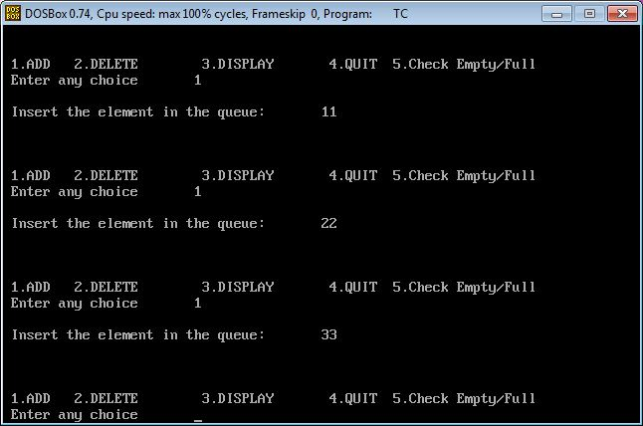

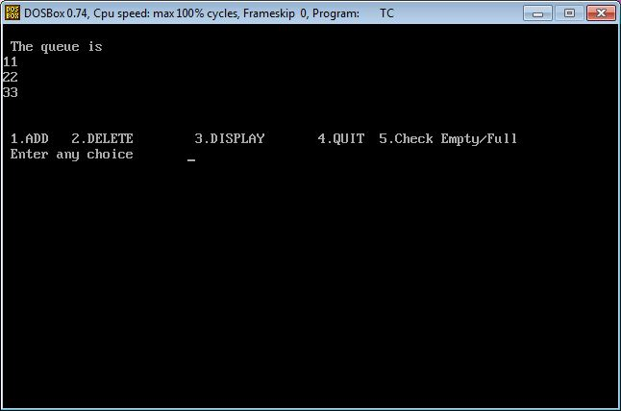

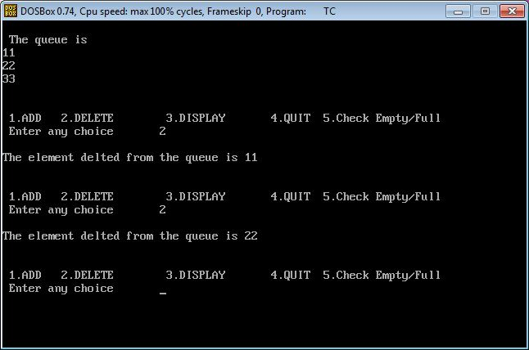

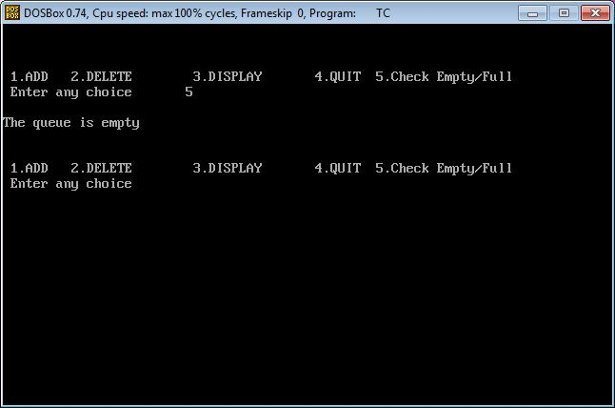

**CONCLUSION:**

Hence, the program was successful, and the linear queue was implemented.